**2 System Environment**

**Structure of the System:**

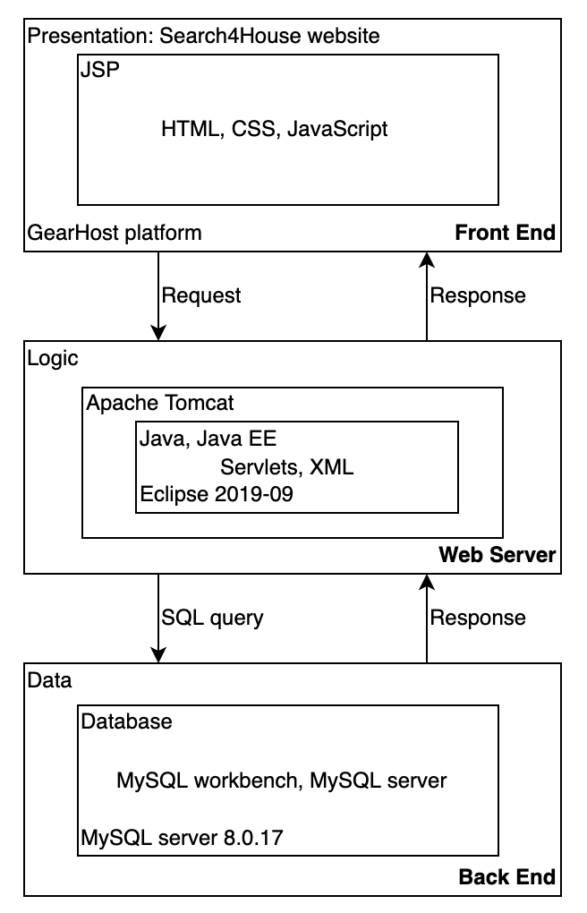

**Hardware/Software:**

1. Apache Tomcat v8.5 Server
   1. Apache Tomcat, an open-source web server, allows users to run their web-based applications developed with Java on their local host servers. With the server, users are able to run Java Server Pages, JSP, files and Java servlets, Java programs.
2. Eclipse IDE for 2019-09
   1. An integrated development environment for Java Enterprise Edition (EE) used for web-development and web-applications. It includes the tools required to develop in both Java and JavaScript.
3. MacOS/Windows OS
   1. Our team will be using both Mac and Windows operating systems based on each members’ preferences. Regardless of the OS, all members will be using the same software to develop the system.
4. GearHost
   1. GearHost is a free web-hosting platform that allows for MySQL database testing. The platform allows users to directly publish from either their computer or from their git, making it easy for us to pull from a local or remote location.

**RDBMS:**

1. MySQL server 8.0.17
   1. Our team will be using MySQL to input, edit, and store our data. The server will be ran within our local host for running and testing during early development.
2. MySQL Workbench v8.0.17
   1. MySQL Workbench is a tool used for MySQL database development that allows users to visually view their database structure and values. Users can also generate and manage their database directly through the workbench.

**Application languages:**

1. Java 8
   1. Our team will be using Java for our main code. Our team is most familiar with this language and with MySQL Connector/J, it would be easy to connect our Java code to MySQL.
2. Java EE
   1. Java EE is built based on the regular Java programming language and also includes required tools for web development. Java EE allows for the 3-tier architecture in web development: presentation, logic, and data.
3. HTML
   1. HTML, Hypertext Markup Language, will be used for designing the basic formatting layout for our website.
4. CSS
   1. CSS, Cascading Style Sheets, will be used for designing the presentation version of our website. It will work along with HTML.
5. JavaScript
   1. JavaScript will be used for dynamic functions that directly communicates with HTML and user interactions and be able to communicate with the database.
6. XML
   1. XML, eXtensible Markup Language, will set rules and constraints on storing and sharing when publishing the data on the internet.
7. SQL
   1. SQL is the language used for MySQL. This will be the primary language used for database management.